### A Project Report On

**Photo-Fenton Degradation of Eosin Yellow Dye using Co-Doped Bismuth Ferrite**

***Submitted in partial fulfilment of the requirement for the award of***

### Bachelors of Technology in

**Chemical Engineering of**

**National Institute of Technology, Raipur**



### Submitted by: Supervised by:

Pushkar Kumar (21113905) **Dr. Prabir Ghosh**

Siddhant Sharma (21113910) (Associate Professor) Soumil Thakurata (21113912)

**DEPARTMENT OF CHEMICAL ENGINEERING NATIONAL INSTITUTE OF TECHNOLOGY, RAIPUR 2024-25**

**DECLARATION**

We hereby declare that the work which is being presented in the project entitled, **“Photo-Fenton Degradation of Eosin Yellow Dye using Co-Doped Bismuth Ferrite”** which is being submitted to National Institute of Technology Raipur for the award of the degree of Bachelor of Technology in Chemical Engineering is a bonafide report of the work carried out by us under the guidance and supervision of Associate Professor Dr. Prabir Ghosh, Department of Chemical Engineering, National Institute of Technology Raipur. We also declare that we have adhered to all principles of academic honesty and integrity and have not misrepresented or fabricated or falsified any idea/data/fact/source in our submission. We have not plagiarized or submitted the same work for the award of any other degree.

Place: NIT Raipur Date: 16.04.2025

**Pushkar Kumar (21113905)**

Siddhant Sharma (21113910)

Soumil Thakurata (21113912)



**NATIONAL INSTITUTE OF TECHNOLOGY, RAIPUR**

**Department of Chemical Engineering**

**G.E. Road, Raipur, Chhattisgarh - 492010**

**CERTIFICATE**

This is to certify that the work which is being presented in the project entitled **“Photo-Fenton Degradation of Eosin Yellow Dye using Co-Doped Bismuth Ferrite”** which is submitted by **Pushkar Kumar (21113905)**, Siddhant Sharma (21113910), Soumil Thakurata (21113912) in partial fulfilment of the requirements for the award of degree of Bachelor of Technology, is a record of the candidate’s own work carried out by him under my supervision. The matter embodied in this project report is original and has not been submitted elsewhere for the award of any other degree.

**Dr. Prabir Ghosh**

(Associate Professor) Department of Chemical Engineering National Institute of Technology, Raipur

**ACKNOWLEDGEMENT**

We are immensely grateful to GOD for providing us with unwavering strength in duration of this project and throughout our academic journey. The success of this major project was made possible by the invaluable guidance and support of numerous individuals, without whom we would not have been able to complete it. We are deeply appreciative of their assistance and will forever be indebted to them.

We extend our heartfelt thanks to **Dr. Prabir Ghosh** (Associate Professor) and, **Amruta Pattnaik** (Research Scholar), **Asha Patra** (Research Scholar) from the Department of Chemical Engineering at National Institute of Technology Raipur for granting us the golden opportunity to undertake research on “Photo-Fenton Degradation of Eosin Yellow Dye using Co-Doped Bismuth Ferrite”.

We would also like to thank Department of Metallurgical and Materials Engineering at National Institute of Technology Raipur for providing us the facilities for SEM and EDX testing.

We would also like to thank Central Instrumentation Facility at Indian Institute of Technology Bhilai for providing us the facility for XRD testing.

We owe a depth of gratitude to Dr. Amit Keshav (Professor & HOD, Dept. of Chemical Engineering) for all the facilities provided during the course of our tenure.

**Pushkar Kumar (21113905)**

Siddhant Sharma (21113910)

Soumil Thakurata (21113912)

|  |  |  |
| --- | --- | --- |
| **Table of Contents** | | **Page No.** |
| **Chapter 1: Introduction** | | 1 |
| 1.1 | General Overview | 1 |
| 1.2 | Eosin Yellow Dye | 2 |
| 1.3 | Nanoparticle Catalysts | 3 |
| 1.4 | BiFeO3 as a Photocatalyst | 3 |
| 1.5 | Advantages of BiFeO3 | 4 |
| 1.6 | Synthesis of BiFeO3 | 5 |
| **Chapter 2: Literature Survey** | | 6 |
| 2.1 | Co-doped BiFeO3 and Applications | 6 |
| 2.2 | Eosin Yellow Degradation | 7 |
| 2.3 | Research Gap | 11 |
| 2.4 | Objective of the Project | 11 |
| **Chapter 3: Materials and Methods** | |  |
| 3.1 | Materials and Equipments for Co-doped BiFeO3 (Sol-Gel Route) Synthesis | 12 |
| 3.2 | Materials and Equipments for degradation of Eosin Yellow Dye | 12 |
| 3.3 | Equipment for SEM and EDX Characterisation | 12 |
| **Chapter 4: Project Overview** | | 13 |
| 4.1 | Synthesis of Photocatalyst | 13 |
| 4.2 | Doping | 13 |
| 4.3 | Characterisation | 13 |
| 4.4 | Degradation Reactions | 13 |
| 4.5 | Kinetic Study | 13 |

|  |  |  |
| --- | --- | --- |
| **Chapter 5: Methodology** | | 14 |
| 5.1 | Synthesis of Co-doped BiFeO3 | 14 |
| 5.2 | Procedure of Degradation Experiments | 14 |
| **Chapter 5: Results and Discussion** | | 15 |
| 6.1.1 | EDX Characterisation of BiFeO3 | 15 |
| 6.1.2 | SEM Characterisation of BiFeO3 | 15 |
| 6.1.3 | XRD Characterisation of BiFeO3 | 16 |
| 6.2.1 | Preparation of Calibration Curve | 17 |
| 6.2.2 | Integral Method of Rate Constant Determination | 19 |
| 6.2.3 | Kinetic Study of Degradation from 200 ppm under Room Light | 19 |
| 6.2.4 | Kinetic Study of Degradation from 10 ppm under Room Light | 20 |
| 6.2.5 | Kinetic Study of Degradation from 10 ppm under Visible Light Irradiation | 23 |
| 6.2.6 | Proposed Mechanisms | 25 |
| **Chapter 7: Conclusion** | | 28 |
| **Chapter 8: Future Scope and Challenges** | | 29 |
| **References** | | 30 |

### List of Tables

|  |  |  |
| --- | --- | --- |
| Table No. | Title of Table | Page No. |
| 6.1 | Calibration Curve | 18 |
| 6.2 | Concentration vs Time Data (1:1 Catalyst, 200 ppm, Room Light) | 19 |
| 6.3 | Concentration vs Time Data of 1:1 doped catalyst (10 ppm, room light) | 21 |
| 6.4 | Concentration vs Time Data of 1:2 doped catalyst (10 ppm, room light). | 21 |
| 6.5 | Concentration vs Time Data (1:1 catalyst, 10 ppm, LED light) | 24 |

**List of Figures**

|  |  |  |
| --- | --- | --- |
| Figure No. | Title of Figure | Page No. |
| 1.1 | Types of Wastewater Treatment | 1 |
| 1.2 | Structure of Eosin Yellow Dye | 3 |
| 1.3 | Structure of BiFeO3 (ball and stick model) | 4 |
| 3.1 | SEM, External View | 12 |
| 3.2 | SEM, Internal View | 12 |
| 5.1 | EDX of Co-Doped BiFeO3 | 15 |
| 5.2 | SEM Images of Co-Doped BiFeO3 | 16 |
| 5.3 | XRD Pattern of Co-doped BiFeO3 | 17 |
| 5.4 | Calibration Curve | 18 |
| 5.5 | Linearised Conversion vs Time Data (1:1 Catalyst, 200  ppm, Room Light) | 20 |
| 5.6 | Degradation Efficiency vs Time (1:1 Catalyst, 200 ppm,  Room Light) | 20 |

|  |  |  |
| --- | --- | --- |
| 5.7 | Linearised Conversion vs Time Data (1:1 Catalyst, 10 ppm, room light) | 22 |
| 5.8 | Linearised Conversion vs Time Data (1:2 Catalyst, 10 ppm, room light) | 22 |
| 5.9 | Degradation Efficiency vs Time (1:1 Catalyst, 10 ppm, room light) | 23 |
| 5.10 | Degradation Efficiency vs Time (1:2 Catalyst, 10 ppm, room light) | 23 |
| 5.11 | Linearised Conversion vs Time Data (1:1 Catalyst, 10 ppm, LED light) | 24 |
| 5.12 | Degradation Efficiency vs Time (1:1 Catalyst, 10 ppm, LED light) | 25 |
| 5.13 | Reduction-hydrogenation model | 26 |
| 5.14 | Reaction Mechanism under Aerobic Conditions Proposed by Martin et al. (2017) | 27 |

**Abstract**

In this study, cobalt doped bismuth ferrite was synthesised via the sol-gel process in order to be used as a photocatalyst in the Photo-Fenton degradation of Eosin Yellow dye solution. The catalysts were prepared with two separate doping ratios and characterised by the analytical techniques of X-ray Diffraction, Energy Dispersive X-Ray and Scanning Electron Microscopy. These analyses confirmed the formation of nanoparticles of the desired composition with only trace impurities being present. The catalyst so synthesised was used to degrade a solution of Eosin Yellow dye via the Photo-Fenton reaction in the presence of hydrogen peroxide. Parameters like light intensity, catalyst used, and initial concentration of dye solution were varied and the degradation efficiencies and reaction kinetics were studied. The results indicated that higher degradation efficiencies were obtained with 2:1 doped Co-doped bismuth ferrite catalyst and increased light irradiation. It was also noted that degradation efficiency was inversely proportional to the initial concentration of the dye solution.

# Introduction

* 1. *General Overview*

Water pollution has become a major global issue, and has reached a crisis-like state in developing and industrialising countries like India. This has been majorly due to increased industrial and urban water consumption, which has led to increased effluent and sewage discharge and thus, to rapidly increasing water pollution. This has led to the development of a variety of treatment methods, usually classified under the physical, chemical and biological methods of water treatment. Water treatment processes have also been classified as primary, secondary or tertiary methods of treatment, depending on the stage at which a specific treatment process is applied.

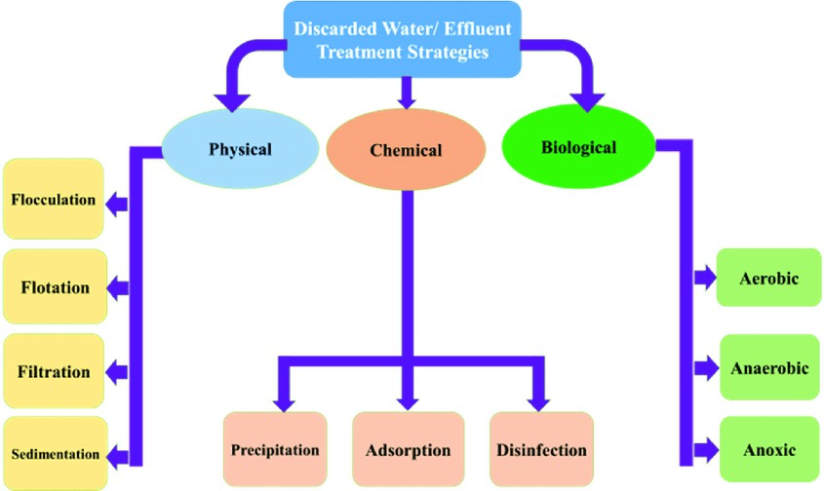

Fig 1.1. Types of Wastewater Treatment (Walia et al., 2020).

However, for all these water treatment methods, organic pollutants and volatile organic compounds (VOCs) present a formidable challenge when it comes to their removal from effluent

streams. Physical methods in this case suffer from the drawback that the pollutants are usually quite miscible with water, while the chemical process suffers from the drawback that copious amounts of chemical dosing is required to remove these pollutants, leading to more harm than good due to the secondary pollution caused during the treatment process. Biological processes overcome this limitation of the water treatment process, but their chief drawback is their slow speed. Due to these shortcomings in present-day commercial wastewater treatment processes, Photo-Fenton based wastewater treatment processes have begun to become more popular in research. In this method, photocatalysts are utilised, which, when excited by either UV or visible light irradiation, degrade the contaminants in the waste water stream. Bismuth Ferrite is one such potent photocatalyst, which can operate well under both UV and visible light irradiation.

* 1. *Eosin Yellow Dye*

Eosin Yellow dye, also known as CI Acid Red 87, is a dye which is a member of the triarylmethane dye family, or a xanthene dye. It is used widely in the field of pathology, for staining the cells before study under a microscope. Its molar mass is 647.89052, with a chemical formula of C20H6Br4Na2O5. It is the most common histological staining dye among the Eosin dye family, mainly due to its use in the Hematoxylin and eosin (H&E) stain. It is also widely used in the paper and textile industry. An acidic dye, it is a very recalcitrant dye and is very difficult to remove or degrade in wastewater streams. Its density is close to that of water at 1.018 g/cm3, with a boiling point of 295.5°C. As it is also very highly soluble in water, physical treatment processes for its removal are ineffective. Eosin Yellow dye has been shown to be carcinogenic for humans, and has the ability to inhibit growth of epithelial cells in the human cornea, and is toxic for the human liver. Due to the widespread use of this dye, significant amounts of this harmful pollutant is discharged everyday into sewage effluents and eventually into our water bodies. It is thus necessary to develop some effective and economical means of degradation of this dye in order to prevent the occurrence of its ill-effects.

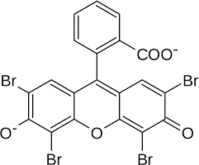

Fig. 1.2. Structure of Eosin Yellow Dye (CAS No. 17372-87-1)

* 1. *Nanoparticle Catalysts*

Photocatalysts are more effective the greater the area of their exposed surface to the pollutant is. Thus, nanoparticles photocatalysts are highly preferred to other catalyst types due to the high available surface area to weight ratio that can be obtained from these catalysts as compared to powder, beads or pellets. Furthermore, as quantum effects begin to affect the catalyst in the nano-size ranges, these nanoparticle catalysts demonstrate enhanced magnetic, electric and photochemical properties. The chief disadvantage of these catalysts are the requirement of high purity, and the high costs associated with their manufacture.

Nanoparticle catalysts can be broadly divided into the following types: metallic oxides, composite metallic oxides, zeolite catalysts, enzyme catalysts (also called nanozymes), and perovskite catalysts. Most nanoparticle photocatalysts form the perovskite structure with the more or less general formula of ABO3. The photocatalytic activity of these catalysts is usually further enhanced by doping with transitional metals like cobalt, manganese or tin. Co-doping has become increasingly popular, with multiple transition metals being used for doping in order to increase the photocatalytic activity of the base catalyst. Techniques like coating with novel materials like graphene oxide has also become popular, with good results on the photocatalytic activity of the base catalyst. However, excessive doping has been observed to lead to a drop in the base catalyst’s photocatalytic activity.

* 1. *BiFeO3 as a Photocatalyst*

Bismuth ferrite has a perovskite structure with a general formula of ABO3. It forms a rhombohedral shape in its ground, crystalline state, with oxygen cations at the centre of the faces

and two cation sites in the lattice (Lam et al., 2017). It has a high melting point of 1170°C, but it begins to decompose into Bi2Fe4O9 and Fe2O3 below this point (Haumont et al., 2008; Lam et al., 2017). Figure 2 demonstrates the structure of BiFeO3, as taken from the Crystallography Open Database (Moreau et al., 1971) and rendered in Vesta.

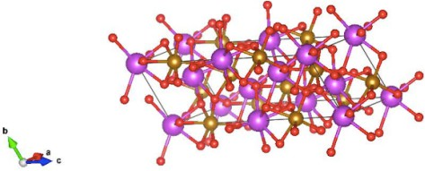

Fig. 1.3. Structure of BiFeO3 (ball and stick model)

* 1. *Advantages of BiFeO3*

The chief reason for the preference of BiFeO3 as the Photo-Fenton catalyst over the conventional FeSO4 is its comparatively narrow bandgap which enhances its catalytic activity. This is because bismuth ferrite is a semiconductor, compared to the metallic nature of ferrous sulphate. Additionally, bismuth ferrite is highly thermally stable up to about 1000°C, and it can demonstrate its electrical, magnetic and multiferroic properties well up to its melting point. This allows this catalyst to be operated with stability over a wide range of temperatures without large adverse effects on its catalytic properties. These factors in total contribute to the increased interest in bismuth ferrite as a photocatalyst.

* 1. *Synthesis of BiFeO3*

BiFeO3 can be and has been synthesised via a variety of routes, ranging from thermal decomposition all the way to electro-spinning deposition methods. The most common ones are usually the hydrothermal synthesis method in an autoclave reactor, sol-gel synthesis method followed by either calcination or roasting, or the co-precipitation method. In the sol-gel method, the precursors are dissolved in a hydrocarbon based solvent like ethylene glycol to form polyols, and bismuth ferrite is then calcined out of the mixture by burning off the solvent. In the hydrothermal method, a strong acid is neutralised into a heterogeneous mixture in order to precipitate out the metallic salts, which in this case is bismuth ferrite. The co-precipitation method requires the addition of precursors to a solvent and then allowing the solution to reach an equilibrium and eventually precipitate out the salt after prolonged drying.

# Literature Survey

* 1. *Co-doped BiFeO3 and Applications*

Paliwal et al. (2017) have utilised the polyol method to synthesise their Co-doped BiFeO3 catalyst. Ethylene glycol was used as the solvent to dissolve the precursors, and the solvent was then boiled off. The main goal of this synthesis was to test the catalyst’s photocatalytic activity, which was tested by measuring the photocatalytic degradation of Evans blue dye in the presence of this catalyst under visible light irradiation. Under the optimised conditions, the optimum pH was observed to be 2.5, and the rate constant value was calculated as being 16.12 x 105 s-1.

Li et al. (2019) utilised a very unconventional method to synthesise their Co-doped BiFeO3. The first step was to synthesise the BiFeO3 from a metal-organic framework (MOF) by dissolving it in an acidic medium. A precipitate was obtained, which was then grinded, followed by calcination to obtain the Co-doped catalyst. The researchers characterised their catalyst by the analytical techniques of XRD, FESEM, and XPS. Since the main goal of this synthesis was to test the photocatalytic activity of the catalyst obtained, the degradation of Methyl Orange in the presence of the catalyst and visible light irradiation was observed. A degradation of 90% under 2 hours was observed.

Khajonrit et al. (2018) synthesised their Co-doped BiFeO3 via the sol-gel route with ethylene glycol as the precursors’ solvent. After the solvent was boiled off, the paste obtained was then calcined to obtain the black coloured Co-doped catalyst. The goal of the study in this case was not to test the photocatalytic activity of the catalyst, but rather to test the variation in magnetic and electrochemical properties of the Co-doped BiFeO3 catalyst as compared to the BiFeO3 catalyst. In regards to size, it was observed that the crystalline size of the particles decreased with increased Cobalt doping, along with a corresponding increase in saturation magnetisation and remanence. It was also noted that increasing Co-doping significantly enhanced the catalyst’s ferromagnetic properties.

* 1. *Eosin Yellow Degradation*

Khalek et al., (2018) synthesised ZnO catalyst, as well as silver and bromine doped ZnO catalyst via the co-precipitation method in the basic medium, and used the catalysts obtained to carry out photocatalytic degradation of a 10 ppm Eosin Yellow solution. The principal observation was the difficulty in dye degradation even in the presence of a catalyst: undoped ZnO catalyst under light irradiation only managed to achieve a degradation of 20%. However, on the addition of AgBr dopant to the catalyst, this degradation jumped to 80+%. Visible light source was utilised in this experiment with varying powers of 200 W to 600 W. It was observed that increase in lamp power led to almost linear increases in degradation efficiencies. The optimum pH values were observed to be 8.03, 6.26 and 7.25 respectively. The reason for this has been assigned to the anionic nature of the Eosin Yellow dye.

Liu et al. (2012) prepared BiOCl and TiO2 catalysts by utilising the reverse micro-emulsion approach. N-hexanol was the co-surfactant, and cyclohexane was used in the oil phase. The photocatalytic degradation of 50 ppm Eosin Yellow solution was carried out by using these catalysts separately, as well as by using them in predetermined ratios. As before, Eosin Yellow proved to be a difficult dye to remove: TiO2 and BiOCl alone only managed degradation rates of 8.3% and 53.7% respectively after 2 hours of reaction. However, once the catalysts were used together in predetermined ratios, the degradation efficiency spiked to as high as 93.6% for a mixture of 50% BiOCl and 50% TiO2. The optimum pH was also determined in this case to be pH 4, with both more basic or more acidic pH leading to reduced degradation efficiencies.

Sunkara & Botsa (2019) utilised the hydrothermal approach for synthesis of SnO2/Fe2O3/Ag nano composite, as well as SnO2/Fe2O3 nano composite. The photocatalytic activity of the catalysts were tested on a 10 ppm Eosin Yellow solution under varying pH and catalyst dosing conditions with visible light irradiation. For SnO2/Fe2O3 nanocomposites, the maximum degradation efficiency was 31%, however, the Ag doped nanocomposites were much more effective, achieving degradation efficiencies of 79%. It was observed that increase in initial catalyst concentration led to significantly lower degradation efficiencies. In this case, in contrast

close to neutral pH being the optimum, a pH of 9 was found out to be the optimum condition for dye degradation.

Zheng et al. (2007) utilised the classic FeSO4.7H2O catalyst to carry out degradation of Eosin Yellow under conditions of both a 450W mercury lamp as well as sunlight. It was observed that even a strong powered UV lamp with catalyst and H2O2 dosing managed to degrade the dye by 50% in case of a 20 ppm Eosin Yellow solution. In contrast, under sunlight, the dye degraded by 90+% with sufficient H2O2 dosing. The optimum pH value in this case was determined to be 3.5 in case of sun as the light source.

Sharma et al. (2017) prepared ZnO catalysts via the co-precipitation route. The ZnO powder so obtained were annealed at different temperatures and their photocatalytic activity was tested by degradation of 0.0001 mol/lit solution of Eosin Yellow (approximately 69 ppm) under solar irradiation. For ZnO powder annealed at 300°C, degradation efficiency of 40% over 90 minutes was observed. However, ZnO powder annealed at 700°C showed a degradation efficiency of nearly 100% over a period of 90 minutes.

Rani Rosaline et al. (2020) synthesised NiO-WO3 nanoparticles by the hydrothermal synthesis method. The Eosin Yellow solution used had a starting concentration of approximately 1 ppm. The experiments were carried out under visible light irradiation and varying pH and catalyst dosings. Under neutral pH conditions, a degradation of 30% was observed, while a pH of 5 showed the maximum degradation of 95%. In fact, it was observed that keeping catalyst dosage too high actually hindered the degradation reaction, as a catalyst dosing of 1 ppm actually led to a higher degradation efficiency as compared to a catalyst dosing of 1.25 ppm.

Alzahrani (2015) synthesised iron oxide nanoparticles by means of sol-gel method followed up with magnetic separation. Additional Ag-doped iron oxide nanoparticles were also prepared by calcining AgNO3 in the presence of iron oxide nanoparticles. The photocatalytic activity of these catalysts were measured by testing the degradation of 276 ppm of Eosin Yellow dye solution under UV irradiation. For only iron oxide nanoparticles, degradation of 40% over 3 hours was

observed. However, on Ag-doping, the degradation over the same time period increased to over 90%.

Ojha & Thareja (2020) synthesised the graphene oxide catalyst via the Hummer’s process to generate graphite oxide and then synthesising graphene oxide from graphite oxide obtained. Both graphene oxide and TiO2 were used separately as well as together to test their photocatalytic activity in a 10 ppm Eosin Yellow dye solution under both white light and UV irradiation, respectively. With white light irradiation, the maximum degradation of the dye in the presence of a mixture of graphene oxide and TiO2 was 50% in 6 hours. However, for the same composition, under UV light irradiation, the degradation of the dye increased to 90% in 6 hours. The optimum pH for the degradation was observed to be at pH 3, however, a pH of 4.5 gave nearly the same degradation of the dye.

Farouq et al. (2022) utilised purchased ZnO nanoparticles to carry out photocatalytic degradation of Eosin Yellow dye solutions at concentrations ranging from 15 ppm to 150 ppm in a UV irradiated continuous plug flow reactor. For 100 ppm solutions, the maximum degradation peaked at 40%, however, better results were observed at 15 ppm, with peak degradations of 65% under 80 minutes. In this case, varying the pH did not lead to significant improvements in degradation, with degradation at pH 3.5 being only marginally better than degradation at pH 5, 3 or 7 respectively.

Karthik et al. (2017) synthesised Ag-doped nanoparticle catalysts obtained from the extract of *Camellia japonica* leaves. The photocatalytic activity of the catalyst was then measured by carrying out photocatalytic degradation of 10 ppm Eosin Yellow dye solution under constant light irradiation. Degradation efficiencies ranging from 50% to 90% were observed with varying catalyst dosings, however, increase in catalyst dosing beyond 50 ppm actually led to a decrease in degradation efficiency.

Raja et al. (2018) synthesised their Zn2SnO4 and their V2O5 nanoparticles via the hydrothermal route. Their Zn2SnO4-V2O5 nanocomposites were prepared via the process of sonochemical deposition in three separate stoichiometric ratios. The photocatalytic activity of these catalysts

separately as well as in their composite form were tested by carrying out degradation of 20 ppm Eosin Yellow dye solution under visible light irradiation. For V2O5 and Zn2SnO4 catalysts alone, degradation efficiencies of 30% and 40% under 3 hours respectively, were observed. However, the composite nanoparticles demonstrated much higher degradation efficiencies, with the highest degradation efficiency being 90% under 3 hours. The optimum pH in this case was determined to be 4, and higher Eosin Yellow dye removal efficiencies were observed at low starting concentrations, especially at 1 ppm.

Oppong et al. (2018) utilised pre-synthesised zinc oxide, as well as zinc oxide and graphene oxide composites, as well as lanthanum doped zinc oxide and graphene oxide composites as their photocatalysts for degradation of Eosin Yellow dye. A degradation of 15% with pure ZnO catalyst, 40% with ZnO-graphene oxide nanocomposite catalyst, and near 90% degradation rates with La-doped ZnO-graphene oxide nanocomposite catalysts were observed under a period of 4 hours. It was observed that increased lanthanum doping in the catalyst dramatically increased the degradation rate of the dye in solution.

Chakrabarti & Dutta (2004) also utilised pre-synthesised zinc oxide nanoparticle catalysts. The catalyst was used to carry out Eosin Yellow dye solution degradation under UV light irradiation and aerobic conditions, which was maintained by bubbling air through the solution via a compressor. For an initial dye concentration of 50 ppm, degradation rates ranging from 40% to 70% were observed under two hours, however, excessive amounts of catalyst (in the order of 200 ppm) were required to achieve the higher degradations. It was also noted that increasing the wattage of the UV light source was directly correlated to increased degradation rates in the dye.

Oppong et al. (2019) utilised the sonochemical method to synthesise the Ce-ZrO2-Graphene Oxide and zirconium oxide-graphene oxide nanocomposite catalyst. Furthermore, they also synthesised pure ZrO2 and Ce(NO3)2.6H2O for comparing the photocatalytic activity of these two nanoparticles with the composite catalyst. The catalytic activity of these three catalysts was tested by degradation of a 20 ppm Eosin Yellow dye solution under powerful UV lamp irradiation (150 W). Pure zirconium oxide gave negligible degradation efficiency. However, the zirconium oxide-graphene oxide nanocomposite gave a relatively better degradation of 20%

under three hours. However, cerium-doped nanocomposites gave drastically better degradation efficiencies ranging from 50% to over 90% in under three hours. The optimum cerium doping ratio was determined to be 0.3% cerium by weight.

* 1. *Research Gap*

Although the degradation of the Eosin Yellow dye itself has been studied widely, there is still no paper as of yet that has studied the behaviour of the dye and its degradation in the presence of BiFeO3, especially Co-doped BiFeO3. Eosin Yellow is a very recalcitrant dye, as can be seen from the large literature cited above where the removal rates of the dye are very low, usually below 50%, even after prolonged irradiation by powerful light sources for long periods of time. This project has attempted to bridge this shortcoming as one of its objectives.

* 1. *Objective of the Project*

The objectives of this project are:

* + - To synthesize BiFeO3 photocatalyst nanoparticles doped with cobalt in two separate molar ratios (1:1 and 2:1) via sol-gel route.
    - To characterize Co-Doped BiFeO3 nanoparticles by analytical techniques like EDX, SEM and XRD.
    - To carry out Photo-Fenton degradation of Eosin Yellow Dye in a batch reactor under different reaction conditions.
    - To carry out kinetic study (determination of rate constant) of degradation reaction and study of its reaction mechanism.

# Materials and Methods

* 1. *Materials and Equipments for Co-doped BiFeO3 (Sol-Gel Route) Synthesis*

Ferric nitrate nonahydrate (Fe(NO3)3.9H2O) (98% pure), bismuth nitrate pentahydrate (Bi(NO3)3.5H2O) (98% pure), Ethylene glycol (99% concentration), cobalt nitrate hexahydrate (Co(NO3)2.6H2O) (97% pure), nitric acid (HNO3) (70% concentration), muffle furnace, Whatman filter paper, two beakers, magnetic stirrer, hot air oven, ceramic crucible, conical flask.

* 1. *Materials and Equipments for degradation of Eosin Yellow Dye*

Eosin Yellow dye, Potassium Hydroxide (KOH) (Extra Pure), Magnetic Stirrer, Magnetic Bead, 1 Two Litre Beaker, 1 One Litre Beaker, Test Tubes.

* 1. *Equipment for SEM and EDX Characterisation*

Integrated SEM-EDX equipment, Oxford Instruments.

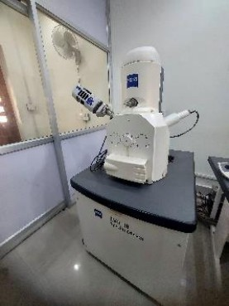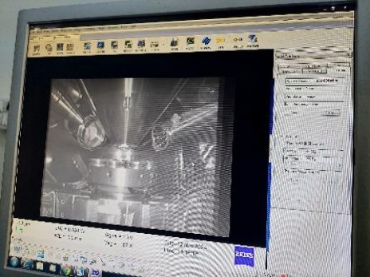

Fig 3.1. SEM, External View Fig 3.2. SEM, Internal View

# Project Overview

* 1. *Synthesis of Photocatalyst*

Co-doped BiFeO3 was synthesised via the sol-gel route with with the precursors being the nitrates of the metallic components of the catalyst.

* 1. *Doping*

Doping of the catalyst was carried out in two separate molar ratios of Co:Bi of 1:1 and 2:1 respectively.

* 1. *Characterisation*

The catalyst was characterised via the analytical techniques of SEM (Scanning Electron Microscopy), EDX (Energy Dispersive X-ray), and XRD (X-Ray Diffraction).

* 1. *Degradation Reactions*

Reaction runs were carried out under varying reaction conditions and the concentration vs. time data was collected.

4.5. *Kinetic Study*

The concentration vs. time data were analysed to conduct a kinetic study.

# Methodology

* 1. *Synthesis of Co-doped BiFeO3*

The solvent used in this sol-gel method was ethylene glycol, 15 ml of which was carefully measured into a beaker and stirring was started via the magnetic stirrer. 0.01 mol each of the precursors bismuth nitrate (4.8507 gms), ferric nitrate (4.04 gms) and cobalt nitrate (2.9103 gms) were added to the solvent and then allowed to dissolve fully. For preparation of the 2:1 Co-doped catalyst, the amount of cobalt nitrate was doubled to 0.02 mol or 5.8206 gms. After complete dissolution of the precursors in the solvent, heating was started at a slow rate in order to evaporate out the solvent as much as possible. Heating at 100°C with careful temperature control for 2 hours was sufficient to obtain a thick paste which could be calcined in the muffle furnace in a crucible. In the muffle furnace the paste was heated at 600°C for 3 hours. A black, oxidised powder was obtained which was washed with 20% conc. (v/v) nitric acid. The washing was carried out in order to remove Bi2O3 particles that may have formed in the crucible. After washing, the powder obtained was dried in a hot air oven at 100°C until a bone dry powder was obtained. The powder was then further crushed with a mortar and pestle and then stored for further analysis.

* 1. *Procedure of Degradation Experiments*

400 ml of reaction mixture was prepared by either using the stock solution (200 ppm) itself, or diluting the stock solution to 10 ppm by mixing 20 ml of 200 ppm Eosin Yellow dye solution with 380 ml of water. Parallely, a 0.01 mol KOH solution was prepared by dissolving 0.1285 gms of KOH in 230 ml of distilled water. The KOH solution was used to adjust the pH of the reaction mixture to 6-7. Three experiments were carried out at room light. One experiment was carried out under visible light irradiation of a 50W LED bulb. 0.011 gms of the catalyst was added to the reaction mixture under stirring condition. 3 ml of H2O2 was then added to the reaction mixture and the stopwatch was accordingly. For experiments conducted at room light, samples were taken out every 15 minutes. For the experiment conducted under visible light irradiation, the sample was taken out every 10 minutes after allowing the catalyst to reach adsorption equilibrium under visible light irradiation for one hour.

# Results and Discussion

6.1.1. *EDX Characterisation of Co-doped BiFeO3*

Peaks were observed as expected for Bismuth, Iron, Cobalt and Oxygen. The peaks for carbon can is due to the use of carbon tape inside the EDX machine, and is a common impurity in most EDX analysis studies.

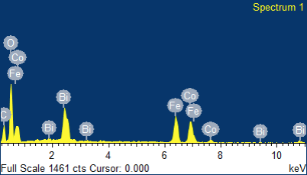

Fig 5.1. EDX of Co-Doped BiFeO3

* + 1. *SEM Characterisation of Co-doped BiFeO3*

At 10K magnification, a cave-like network was observed in the powder. At this magnification, the powder appears crystalline.. At 500 magnification, holes with diameters 20 micrometers and under were observed. The powder appears somewhat amorphous at this magnification. At 7.5K magnification, 2 micrometre and below length clumps were observed, arranged in a sand-bar type arrangement.

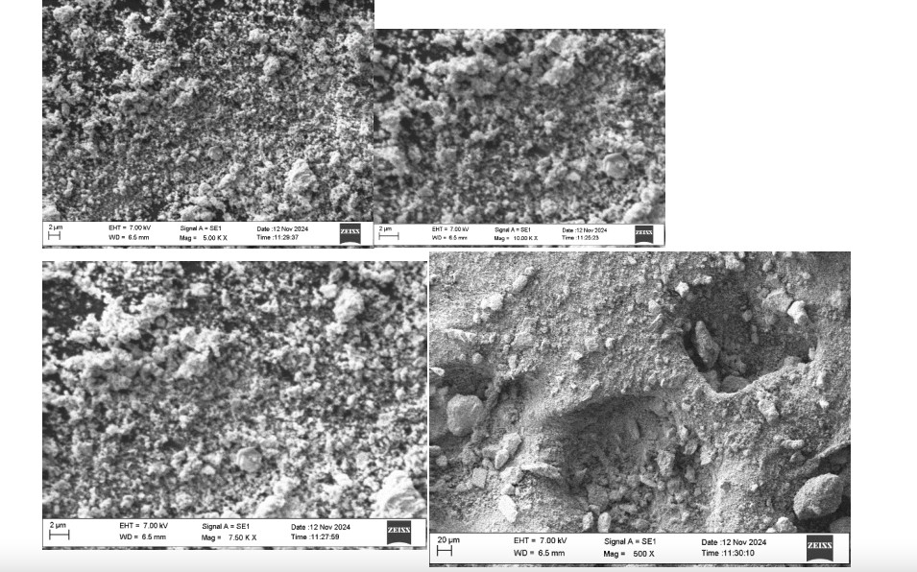

Fig 5.2. SEM Images of Co-Doped BiFeO3 (clockwise: 1. 5K Magnification, 2. 10K Magnification, 3. 500 Magnification, 4. 7.5K Magnification)

* + 1. *XRD Characterisation of Co-doped BiFeO3*

Peaks were observed corresponding to (012), (110), (202), (024) and (116) planes at angles of 23°, 30°, 40°, 45° and 55°, which is consistent with standard BiFeO3 XRD peaks as given in JCPDS Card No. 01-073-0548. The extra peaks other than these standard ones are explained by the presence of the doping element cobalt. The intensity of the XRD peaks is also slightly less than the standard, which is the expected observation after doping.

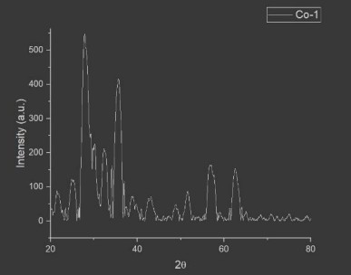

Fig 5.3. XRD Pattern of Co-doped BiFeO3

* + 1. *Preparation of Calibration Curve*

200 ppm Eosin Yellow dye solution was first prepared by dissolving 400 mg of the dye powder in 2 litres of water. A dilute 10 ppm solution was then prepared from the stock solution for photometric analysis. The maximum absorbance wavelength of the 10 ppm dye solution was determined to be at 517 nm with distilled water as the blank sample.

Subsequently, the calibration curve was determined with a step size of 1 ppm, ranging from 10 ppm all the way to 1 ppm.

|  |  |
| --- | --- |
| Absorbance | Concentration (ppm) |
| 1.127 | 10 |
| 0.694 | 9 |
| 0.452 | 8 |
| 0.484 | 7 |
| 0.419 | 6 |
| 0.283 | 5 |

|  |  |
| --- | --- |
| Absorbance | Concentration (ppm) |
| 1.127 | 10 |
| 0.239 | 4 |
| 0.117 | 3 |
| 0.061 | 2 |
| 0 | 1 |

Table 6.1: Calibration Curve

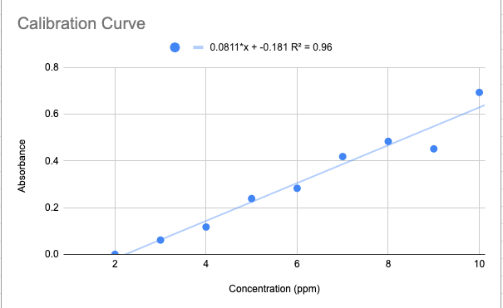

Fig 5.4. Calibration Curve

The linearised equation of the calibration curve was determined by the method of least squares, and yielded the equation:

y= 0.0811x - 0.181, with a R2 value of 0.96 indicating an almost complete linear fit. Thus, the calibration curve obtained can be directly used to determine the concentration of the sample from the absorbance values read by the machine.

* + 1. *Integral Method of Rate Constant Determination*

We utilised the integral method for calculating the rate constant. For a first order reaction, we know that,

𝐶

ln( 0 ) = kt …(1)

𝐶

The rate constant k can thus be determined by linearising the plot of natural log of the concentration ratios vs. time, and the slope of the straight line obtained will be the reaction rate k.

* + 1. *Kinetic Study of Degradation from 200 ppm under Room Light*

0.011 gms of catalyst doped with cobalt in 1:1 ration was used for this degradation run. 400 ml of 200 ppm Eosin Yellow reaction mixture was degraded under room light conditions and constant stirring. A maximum degradation of 14.72% after 2 hours was obtained.

|  |  |
| --- | --- |
| Time (min) | Concentration (ppm) |
| 0 | 200 |
| 15 | 195.58 |
| 30 | 193.74 |
| 45 | 191.46 |
| 60 | 188.74 |
| 75 | 186.28 |
| 90 | 184.88 |
| 105 | 171.54 |
| 120 | 170.56 |

Table 6.2: Concentration vs Time Data (1:1 Catalyst, 200 ppm, Room Light)

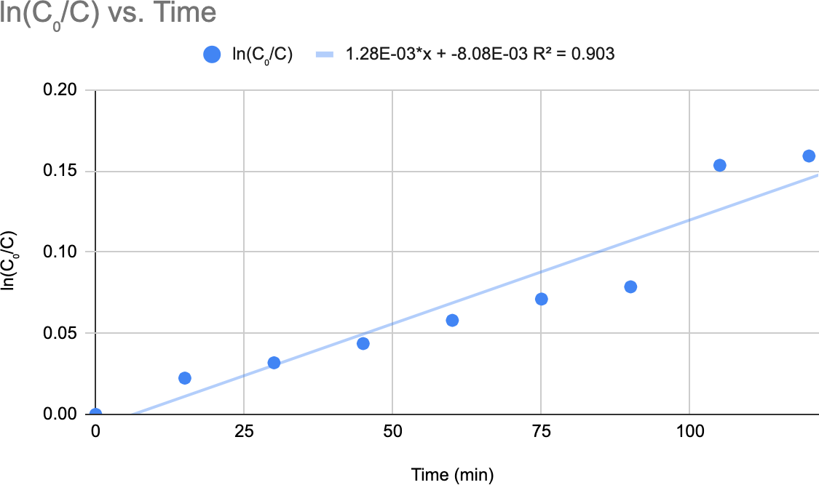

Fig 5.5. Linearised Conversion vs Time Data (1:1 Catalyst, 200 ppm, Room Light) From the linear equation obtained, we can determine the rate constant as 0.00128 min-1.

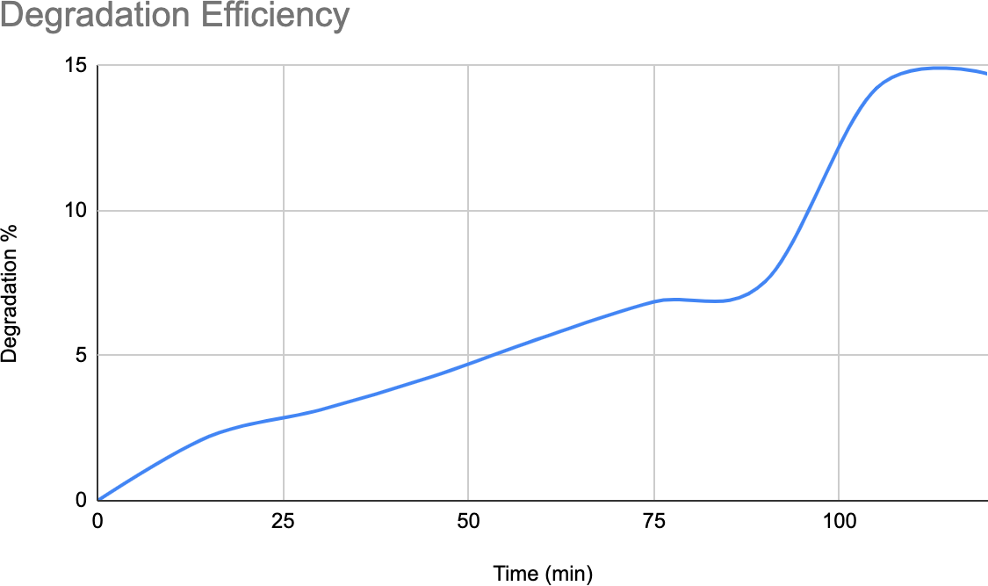

Fig 5.6. Degradation Efficiency vs Time (1:1 Catalyst, 200 ppm, Room Light)

* + 1. *Kinetic Study of Degradation from 10 ppm under Room light*

0.011 gms of both 1:1 Co-doped catalyst and 2:1 Co-doped catalyst were used in this experiment. The starting concentration from which the degradation started was kept at 10 ppm. A maximum

degradation of 23.05% in case of 1:1 doped catalyst and 65.76% in case of 2:1 doped catalyst was observed.

|  |  |
| --- | --- |
| Time (min) | Concentration (ppm) |
| 0 | 10 |
| 15 | 9.687 |
| 30 | 9.573 |
| 45 | 9.314 |
| 60 | 9.152 |
| 75 | 8.986 |
| 90 | 8.439 |
| 105 | 7.701 |
| 120 | 7.695 |

Table 6.3: Concentration vs Time Data of 1:1 doped catalyst (10 ppm, room light).

|  |  |
| --- | --- |
| Time (min) | Concentration (ppm) |
| 0 | 10 |
| 15 | 8.986 |
| 30 | 7.695 |
| 45 | 6.501 |
| 60 | 5.698 |
| 75 | 4.355 |
| 90 | 4.201 |
| 105 | 3.483 |
| 120 | 3.424 |

Table 6.4: Concentration vs Time Data of 2:1 doped catalyst (10 ppm, room light).

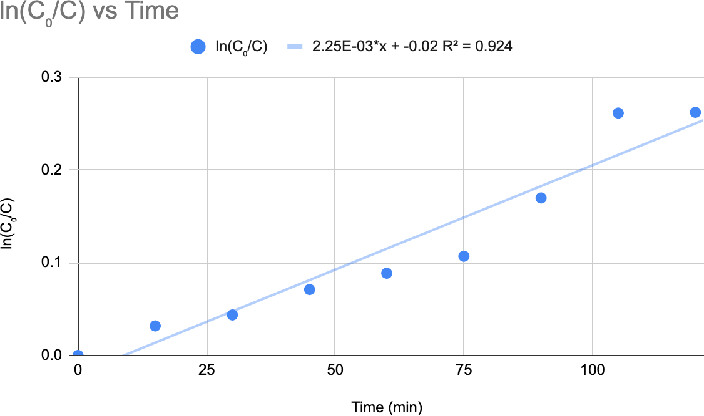

Fig 5.7. Linearised Conversion vs Time Data (1:1 Catalyst, 10 ppm, room light)

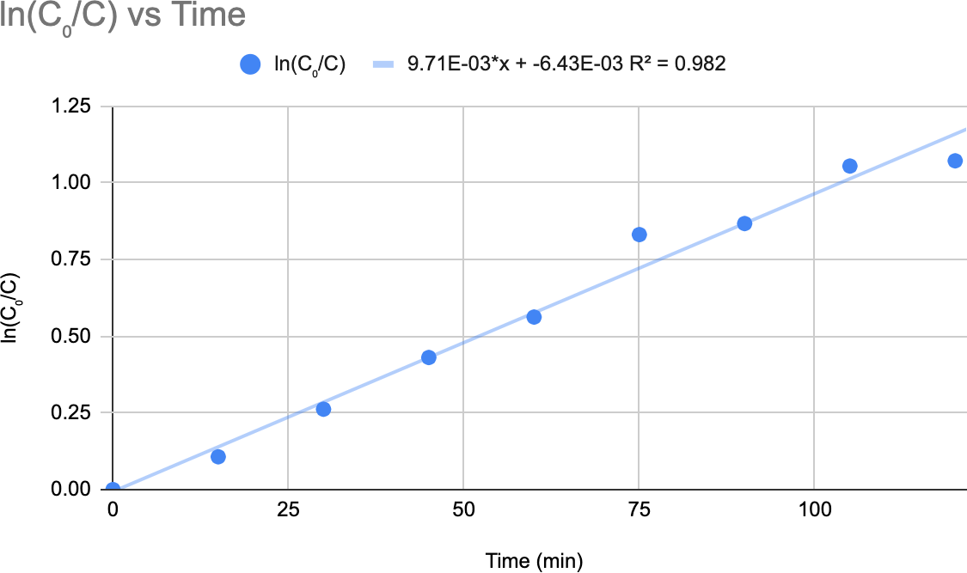

Fig 5.8. Linearised Conversion vs Time Data (2:1 Catalyst, 10 ppm, room

light)

The rate constant for 1:1 and 2:1 catalyst under these conditions was thus determined to be 0.0025 min-1 and 0.00971 min-1 respectively.

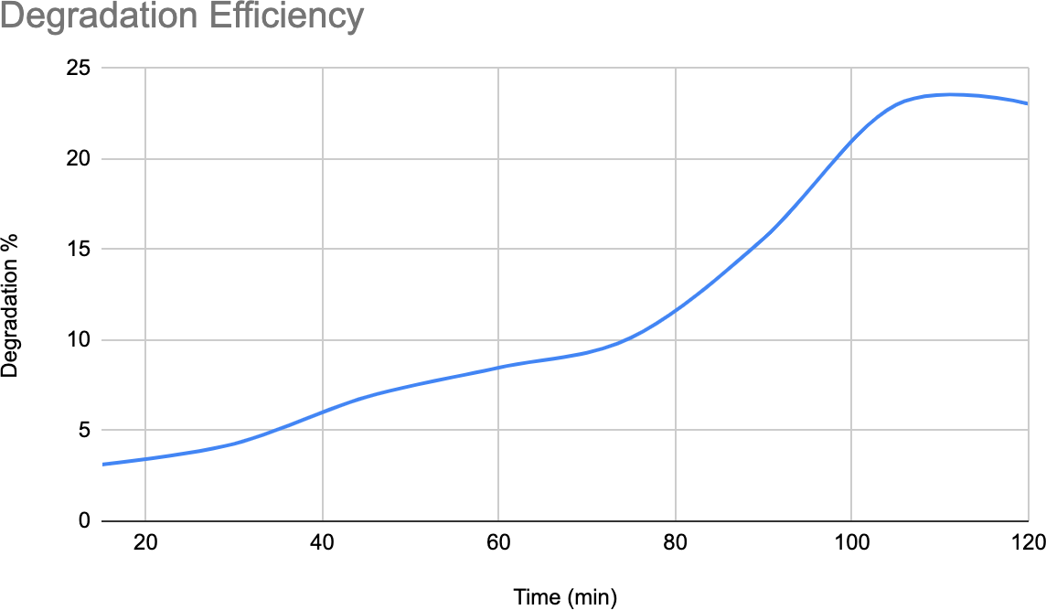

Fig 5.9. Degradation Efficiency vs Time (1:1 Catalyst, 10 ppm, room light)

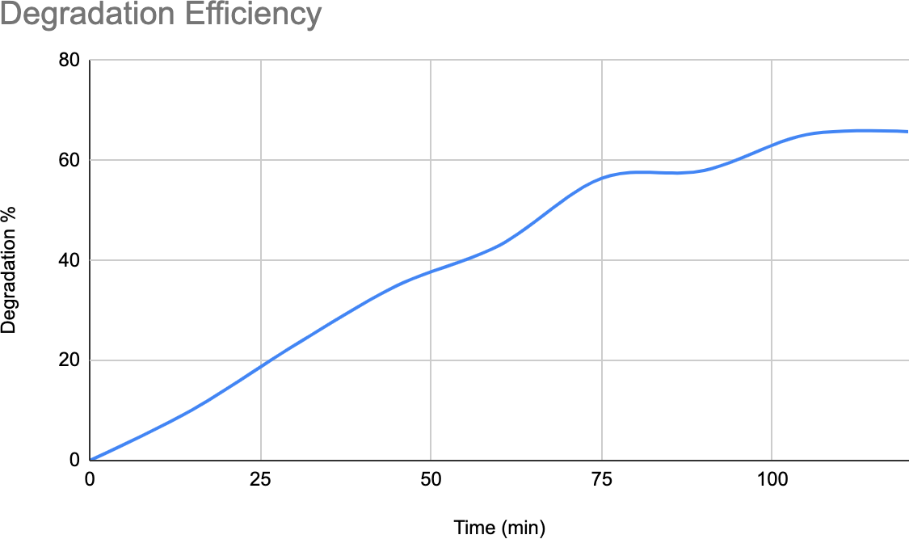

Fig 5.10. Degradation Efficiency vs Time (2:1 Catalyst, 10 ppm, room

light)

* + 1. *Kinetic Study of Degradation from 10 ppm under Visible Light Irradiation*

0.011 gms of 1:1 doped catalyst was used. A 50W LED light bulb was used to provide the visible light irradiation. For the first hour, adsorption equilibrium between the catalyst and pollutant under visible light irradiation was allowed to be reached. After one hour, samples at 10 minutes

were taken for a further two hours. A maximum degradation of 46.7% was observed.

|  |  |
| --- | --- |
| Time (min) | Concentration (ppm) |
| 0 | 10 |
| 60 | 8.016 |
| 70 | 7.573 |
| 80 | 7.612 |
| 90 | 7.412 |
| 100 | 7.62 |
| 110 | 7.223 |
| 120 | 7.364 |
| 130 | 7.167 |
| 140 | 6.66 |
| 150 | 6.501 |
| 160 | 6.636 |
| 170 | 6.05 |
| 180 | 5.897 |
| 190 | 5.653 |
| 200 | 5.295 |
| 210 | 5.33 |

Table 6.5: Concentration vs Time Data (1:1 catalyst, 10 ppm, LED light)

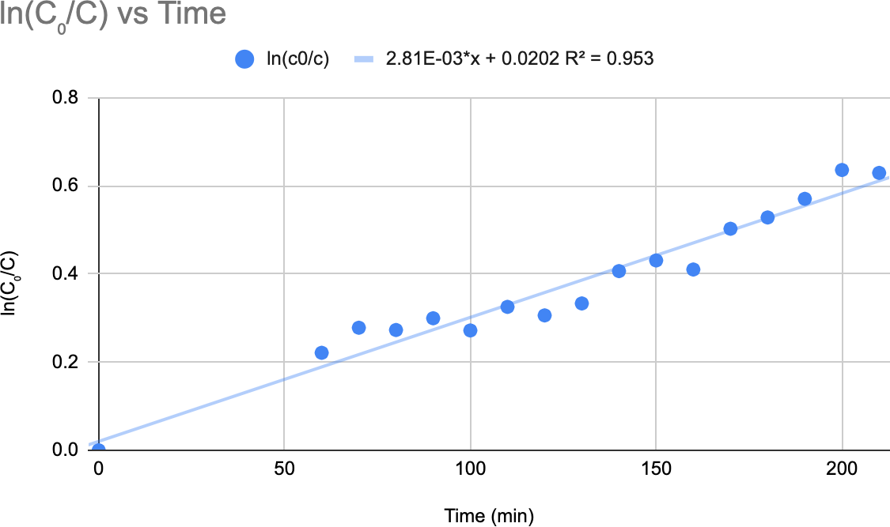

Fig 5.11. Linearised Conversion vs Time Data (1:1 Catalyst, 10 ppm, LED light)

The rate constant of this reaction was thus determined to be 0.00281 min-1.

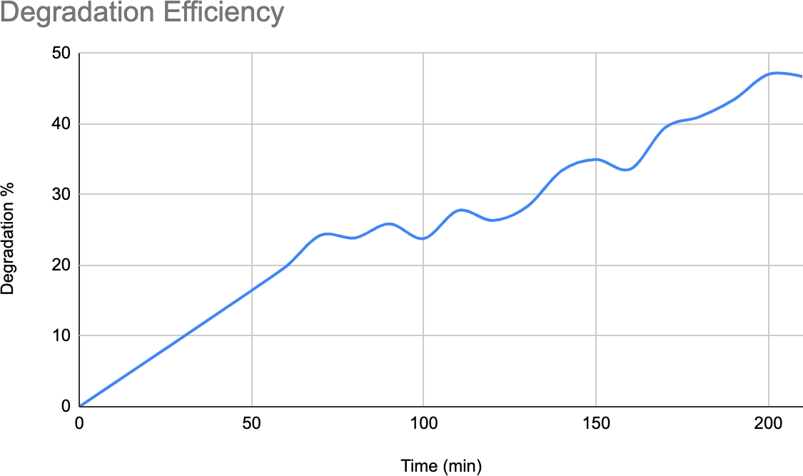

Fig 5.12. Degradation Efficiency vs Time (1:1 Catalyst, 10 ppm, LED light)

6.3 *Proposed Mechanisms*

Haruna et al. (2020) have proposed a simplified but effective mechanism of Photo-Fenton degradation in the presence of bismuth ferrite. The reactions involved in their scheme can be summarised as follows:

BFO (doped or undoped) + hν ➔ e- + h+ e- + O2 ➔ O2- + H2O2

h+ + H2O ➔ OH

O2- + Dye ➔ Degradation Products

**.**OH + Dye ➔ Degradation Products H+ + Dye ➔ Degradation Products

This is the standard representation of Photo-Fenton degradation. Wardman & Candeias (1996) in their review have enlisted a number of competing theories. However, the above is a reasonably good approximation of most of the proposed mechanisms of Photo-Fenton chemistry.

When it comes to the specific degradation pathways of Eosin Yellow dye, the literature is relatively scant. Sabatini et al. (2020) have studied the various degradation products obtained when Eosin Yellow ‘lakes’ are allowed to age naturally by utilising highly accurate liquid chromatography together with mass spectrometry. The chief compounds identified as the degradation products via this method were 3,5-dibromo-2,4-dihydroxybenzoyl benzoic acid, and compounds whose exact structures were not known but rather guessed or proposed by the authors: these compounds were C16H8Br2O5, C17H8Br2O6 and C16H6Br2O4.

Debnath et al. (2015) studied the products of Eosin Yellow degradation via the Photo-Fenton pathway using the liquid chromatography mass spectrometry method, and surprisingly, the degradation products detected were very close to the one detected by Sabatini et. al. (2020) above. The causes ascribed to the occurrence of those compounds were mainly the cleavage of C-O and C-C bond due to attack of hydroxyl radicals, which was facilitated due to the ionisation of the dye molecules in solution.

Wang et al., (2009) proposed a rather simplistic reduction-hydrogenation model to explain the decolorisation of Eosin Yellow under Photo-Fenton conditions. The scheme as described by them is shown below.

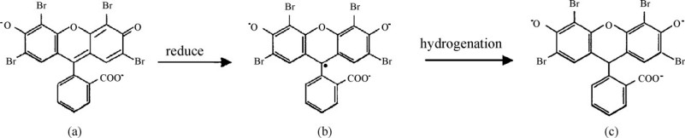

Fig 5.13. Reduction-hydrogenation model (Wang et al., 2009).

Martin et al. (2017) has to date provided the most exhaustive explanation or model of Eosin Yellow degradation under Photo-Fenton conditions in both anaerobic and aerobic conditions. Utilising the LCMS analytical techniques for identifying the Eosin Yellow degradation compounds, several de-brominated and brominated compounds were identified like C20H9O5Br3 and C20H10O5Br2. Due to the observed phenomena of de-bromination, the following mechanism was proposed by the authors for anaerobic and aerobic conditions:

Aerobic conditions: Eosin Y ➔ Eosin Y (-Br) ➔ Decolourisation

Anaerobic conditions: Eosin Y (-Br) ➔ Eosin Y (-2Br) ➔ Formation of Fluorescein

The authors have proposed that the formation of fluorescein under anaerobic conditions is due to the absence of active oxygen radicals preventing the consumption of Eosin Yellow active radicals, thus preventing the formation of highly reactive singlet oxygen radicals and complete decolourisation. However, it was observed that the rate of degradation under anaerobic conditions was faster compared to the rate of degradation under aerobic conditions. However, the equilibrium condition achieved was higher in the case of aerobic condition leading to more complete decolourisation.

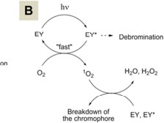

Fig 5.14. Reaction Mechanism under Aerobic Conditions Proposed by Martin et al.

(2017).

# Conclusion

The catalysts were synthesised successfully and the characterisation analysis confirmed that the desired compositions in the catalysts were attained. Highly pure and crystalline Co-doped BiFeO3 was obtained via the sol-gel method. The catalysts were successfully utilised in carrying out degradation of a very recalcitrant anionic dye, Eosin Yellow, and particularly good results were obtained from the 2:1 Co-doped catalyst, which gave the highest degradation of 65.76% in room light under 2 hours.

This study has sought to bridge the gap that existed in the literature regarding degradation of Eosin Yellow dye utilising BiFeO3 catalyst. This study has proven the efficacy of the Co-doped BiFeO3 in its ability to degrade Eosin Yellow in a relatively short time frame of 2-3 hours. This has proven the potential of this material as a powerful photocatalyst that can be used in wastewater treatment on a mass scale basis, if appropriately scaled up, in order to reduce the concentration of difficult to degrade organic compounds in wastewater.

# Future Scope and Challenges

Although the catalyst so synthesised has proven its worth in being able to degrade recalcitrant dyes in wastewater, the final degradation rates achieved, though impressive, are still not sufficient for use on a mass scale. This implies that more doping methods on this catalyst with different materials should be investigated, or perhaps co-doping should be undertaken, in order to improve the photocatalyst further and allow its use in an economical manner for industrial effluent treatment.

The question of cost is the chief challenge of the catalyst synthesised and used in this paper. The precursors used for the synthesis of the Co-doped BiFeO3 catalyst are 10-15 times more expensive than simply purchasing the standard Photo-Fenton catalyst of ferrous sulphate. This significant increase in cost associated with this catalyst precludes its use currently in the industry, unless advancements are made to make the synthesis of bismuth ferrite based catalysts cheaper.

### References

Alzahrani, E. (2015). Photodegradation of Eosin Y Using Silver-Doped Magnetic Nanoparticles.

*International Journal of Analytical Chemistry*.

Chakrabarti, S., & Dutta, B. K. (2004). Photocatalytic degradation of model textile dyes in wastewater using ZnO as semiconductor catalyst. *Journal of Hazardous Materials*, *112*.

Debnath, S., Ballav, N., Nyoni, H., Maity, A., & Pillay, K. (2015). Optimization and mechanism elucidation of the catalytic photo-degradation of the dyes Eosin Yellow (EY) and Naphthol blue black (NBB) by a polyaniline-coated titanium dioxide nanocomposite.

*Applied Catalysis B: Environmental*, *163*.

Farouq, R., Ismaeel, E. K., & Monazie, A. M. (2022). Optimized Degradation of Eosin Dye Through UV-ZnO NPs Catalyzed Reaction. *Journal of Fluorescence*, *32*.

Haruna, A., Abdulkadir, I., & Idris, S. O. (2020). Photocatalytic activity and doping effects of BiFeO3 nanoparticles in model organic dyes. *Heliyon*, *6*.

Haumont, R., Kornev, I. A., Lisenkov, S., Bellaiche, L., Kreisel, J., & Dkhil, B. (2008). Phase stability and structural temperature dependence in powdered multiferroic BiFeO3.

*Physical Review B*, *78*.

Karthik, R., Govindasamy, M., Chen, S. M., Cheng, Y. H., Muthukrishnan, P., Padmavathy, S., & Elangovan, A. (2017). Biosynthesis of silver nanoparticles by using Camellia japonica leaf extract for the electrocatalytic reduction of nitrobenzene and photocatalytic degradation of Eosin-Y. *Journal of Photochemistry & Photobiology, B: Biology*, *170*.

Khajonrit, J., Wongpratat, U., Kidkhunthod, P., Pinitsoontorn, S., & Maensiri, S. (2018). Effects of Co doping on magnetic and electrochemical properties of BiFeO3 nanoparticles.

*Journal of Magnetism and Magnetic Materials*, *449*, 423-434.

Khalek, A., Mahmoud, S. A., & Zaki, A. H. (2018). Visible light assisted photocatalytic degradation of crystal violet, bromophenol blue and eosin Y dyes using AgBr-ZnO nanocomposite. *Environmental Nanotechnology, Monitoring & Management*, *9*.

Lam, S. M., Sin, J. C., & Mohamed, A. R. (2017). A newly emerging visible light-responsive BiFeO3 perovskite for photocatalytic applications: A mini review. *Materials Research Bulletin*, *90*.

Li, Z., Cheng, L., Zhang, S., Wang, Z., & Fu, C. (2019). Enhanced photocatalytic and magnetic recovery performance of Co-doped BiFeO3 based on MOFs precursor. *Journal of Solid State Chemistry*, *279*.

Liu, Z., Xu, X., Fang, J., Lu, X., & Li, B. (2012). Synergistic Degradation of Eosin Y by Photocatalysis and Electrocatalysis in UV Irradiated Solution Containing Hybrid BiOCl/TiO2 Particles. *Water, Air, & Soil Pollution*, *223*.

Lu, J., Günther, A., Mayr, F., Krohns, S., Lunkenheimer, P., Pimenov, A., Travkin, V. D., Mukhin, A. A., & Loidl, A. (2010). On the room temperature multiferroic BiFeO3: magnetic, dielectric and thermal properties. *The European Physical Journal B*, *75*.

Martin, A. A., Trashin, S., Cuykx, M., Covaci, A., Wael, K. D., & Janssens, K. (2017).

Photodegradation mechanisms and kinetics of Eosin-Y in oxic and anoxic conditions.

*Dyes and Pigments*, *145*.

Mittal, J., Jhare, D., Vardhan, H., & Mittal, A. (2013). Utilization of bottom ash as a low-cost sorbent for the removal and recovery of a toxic halogen containing dye eosin yellow. *Desalination and Water Treatment*, *52*.

Moreau, J. M., Michel, C., Gerson, R., & James, W. J. (1971). Ferroelectric BiFeO3 X-ray and neutron diffraction study. *Journal of Physics and Chemistry of Solids*, *32*.

Ojha, A., & Thareja, P. (2020). Graphene-based nanostructures for enhanced photocatalytic degradation of industrial dyes. *Emergent Materials*, *3*.

Oppong, S. O., Anku, W. W., Opoku, F., Shukla, S. K., & Govender, P. P. (2018).

Photodegradation of Eosin Yellow Dye in Water under Simulated Solar Light Irradiation Using La–Doped ZnO Nanostructure Decorated on Graphene Oxide as an Advanced Photocatalyst. *Chemistry Select*, *3*.

Oppong, S. O., Opoku, F., Anku, W. W., Kiarii, E. M., & Govender, P. P. (2019). Experimental and Computational Design of Highly Active Ce–ZrO2–GO Photocatalyst for Eosin Yellow Dye Degradation: The Role of Interface and Ce3+ Ion. *Catalysis Letters*, *149*.

Paliwal, A., Ameta, R., & Ameta, S. C. (2017). Enhancing Photocatalytic Activity of Bismuth Ferrite By Doping With Cobalt And Its Use For Degradation of Evans Blue. *European Chemical Bulletin*, *6*.

Raja, V. R., Rosaline, D. R., Suganthi, A., & Rajarajan, M. (2018). Facile sonochemical synthesis of Zn2SnO4-V2O5 nanocomposite as an effective photocatalyst for degradation of Eosin Yellow. *Ultrasonics Sonochemistry*, *44*.

Rani Rosaline, D., Inbanathan, S., Suganthi, A., Rajarajan, M., Kavitha, G., Srinivasan, R., Hegazy, H., Umar, A., Algarni, H., & Manikandan, E. (2020). Visible-Light Driven Photocatalytic Degradation of Eosin Yellow (EY) Dye Based on NiO-WO3 Nanoparticles. *Journal of Nanoscience and Nanotechnology*, *20*.

Sabatini, F., Eis, E., Degano, I., Thoury, M., Bonaduce, I., & Tenorio, A. L. (2020). The issue of eosin fading: A combined spectroscopic and mass spectrometric approach applied to historical lakes. *Dyes and Pigments*, *180*.

Sharma, N., Jha, R., Baghel, S., & Sharma, D. (2017). Study on photocatalyst Zinc Oxide annealed at different temperatures for photodegradation of Eosin Y dye. *Journal of Alloys and Compounds*, *695*.

Sunkara, J. R., & Botsa, S. M. (2019). SnO2/Fe2O3/Ag Nanocomposite via Hydrothermal Approach: A Novel Highly Efficient Photodegradation of Eosin Yellow and Brilliant Green Dyes Under Visible Light Irradiation. *Chemistry Africa*, *2*.

Walia, A., Bhatia, R. K., Sakhuja, D., & Mundhe, D. (2020). Renewable Energy Products through Bioremediation of Wastewater. *Sustainability*, *12*.

Wang, F., Shao, M., Cheng, L., Chen, D., Fu, Y., & Ma, D. D. (2009). Si/Pd nanostructure with high catalytic activity in degradation of eosin Y. *Materials Research Bulletin*, *44*.

Wardman, P., & Candeias, L. P. (1996). Fenton Chemistry: An Introduction. *Radiation Research*, *145*.

Zheng, H., Pan, Y., & Xiang, X. (2007). Oxidation of acidic dye Eosin Y by the solar photo-Fenton processes. *Journal of Hazardous Materials*, *141*.

Photo-Fenton Degradation of Eosin Yellow Dye using Co-

Doped Bismuth Ferrite

*by* Soumil Thakurata

Submission date: 15-Apr-2025 11:33AM (UTC+0530)

Submission ID: 2646663598

File name: Soumil_8th_Project_Final.pdf (2.45M)

Word count: 7871

Character count: 41159

Photo-Fenton Degradation of Eosin Yellow Dye using Co- Doped Bismuth Ferrite

13

ORIGINALITY REPORT

%

SIMILARITY INDEX

10%

INTERNET SOURCES

8%

PUBLICATIONS

5%

STUDENT PAPERS

PRIMARY SOURCES

1

2

3

4

5

6

7

8

9

10

## Submitted to National Institute of Technology, Raipur

Student Paper

## link.springer.com

Internet Source

## [www.mdpi.com](http://www.mdpi.com/)

Internet Source

## dokumen.pub

Internet Source

## nimrobotics.com

Internet Source

## [www.saddleback.edu](http://www.saddleback.edu/)

Internet Source

## [www.rgipt.ac.in](http://www.rgipt.ac.in/)

Internet Source

## Submitted to Ahmadu Bello University

Student Paper

## "Green Photocatalytic Semiconductors",

Springer Science and Business Media LLC, 2022

Publication

## Tamara Tatrishvili, Marc Jean Médard Abadie. "Advanced Topics in Polymer Chemistry and

3%

1%

1%

<1%

<1%

<1%

<1%

<1%

<1%

<1%